**HEALTH IS WEALTH**

A

*MINI PROJECT REPORT*

*Submitted in partial fulfilment of the Requirements for the award of the Degree of*

*BACHELOR OF ENGINEERING*

*IN*

*INFORMATION TECHNOLOGY*

*BY*

*M.NAGESH 1602-18-737-085.*

*B.MANOJ KUMAR 1602-19-737-082.*

*B.SRI KANISHKA REDDY 1602-19-737-111.*

**

*Department of Information Technology .*

*Vasavi College of Engineering (Autonomous).*

**

*(Affiliated to Osmania University).*

*Ibrahimbagh, Hyderabad-31*

**DECLARATION BY THE CANDIDATE**

*We, M.Nagesh , B.Manoj kumar and B.Sri Kanishka Reddy.Bearing hall ticket numbers, 1602-18-737-085 , 1602-19-737-082 and 1602-19-737-111 , hereby declare that the project report entitled “HEALTH IS WEALTH” is submitted in partial fulfilment of the requirement for the award of the degree of Bachelor of Engineering in Information Technology.*

*This is a record of bonafide work carried out by us and the results embodied in this project report have not been submitted to any other university or institute for the award of any other degree or diploma.*

*M.Nagesh*

*1602-18-737-085*

*B.Manoj Kumar*

*1602-19-737-082*

*B.Sri Kanishka Reddy*

*1602-19-737-111*

**(Faculty In-Charge) (Head.Dept)**

**TABLE OF CONTENT :-**

***1.)Cover sheet (Title of the Project,Team members,Guides).***

***2.)Declaration By The Candidates.***

***3.)Acknowledgements.***

***4.)Abstract***

***i.)Introduction .***

***ii.)Project Ideas.***

***5.)Technology***

***i.)Hardware Requirements.***

***ii.)Software Requirements.***

***6.)Proposed Work***

***i.)Design***

***i.)Use case diagram.***

***ii.)Flowchart.***

***ii.)Implementation***

***i.)Description of main module , highlighting any algorithm.***

***ii.)Github links and folder structures***

***7.)Result***

***8.)Discussion of Future Work***

***9.)References***

**Acknowledgements**

*The satisfaction that accompanies the successful completion of this project would not be in complete without the mention of the people who made it possible, without whose constant guidance and encouragement would have made efforts go in vain. We consider ourselves privileged to express gratitude and respect towards all those who guided us through the completion of this project.*

*We convey thanks to my project guide Mrs.Prasanna of Information technology Department for providing encouragement, constant support and guidance which was of a great help to complete this project successfully.*

*Last but not the least, we wish to thank our parents for financing our studies in this privileged Vasavi College of Engineering as well as for constantly encouraging us to learn engineering. Their personal sacrifice in providing this opportunity to learn engineering is gratefully acknowledged.*

**ABSTRACT**

***Introduction***

*Now a days in this busy world people are not bothering of their health conditions and falling sick very often.*

*What is this health? It is a state of complete physical,mental and social well being and not merely the absence of disease or infirmity.*

*Health is wealth which is a very profound slogan. Yes and that’s true if a person is healthy then he will be able work very actively and efficiently.*

*For good health not exercise and yoga but also a healthy diet is also required.*

*So in our project we are going to work on this.*

**PROJECT IDEAS**

*First a person has to enter his name, age, weight in kilograms and height in meters .*

*Then it calculates the BMI (Body mass index)*

*After calculating BMI we have classified the obtained BMI values into 4 categories.*

*For each category there will be a separate diet in that how many calories have to be taken per day including vitamins intake , and also how much water to drink a day and suitable sleeping times will also be suggested etc.*

*A decent diet is very important for a person to lead a healthy life. Health is the most precious this for an individual. So be wealthy by being healthy 💪🏻.*

**TECHNOLOGY :-**

**All compute software needs certain hardware components or other software components resources to be present. In order for computesr to used efficiently these are the primary requestisites. There are two different categories of this section.**

**i.) Software Requirements :-**

**Software requirements mainly share out with defining the software resource requirements that need to be installed on a computer to provide optimal functioning of a particular application. Therse conditions are not included in the software installation package and need to be installed separately.**

**In order to use Health is Wealth System the following are the prerequisties,**

**a. Operating System – Windows 7 and above**

**b. C Compiler – GNU Compiler**

**c. Editor – Any basic editor is preferable (Example: Notepadd++)**

**ii.) Hardware Requirements :-**

**Hardware requirements refer to the common set requirements defined by any operating system or software application and are usually the physical computer resources. In this section we basically deal with primary memory, secondary memory, processing power.**

**In order to use Health is Wealth System one should have the following,**

**a. Processor - Intel Core i5 and above**

**b. Memory – 4GB Ram**

**PROPOSED WORK**

**i.)Use case diagram**

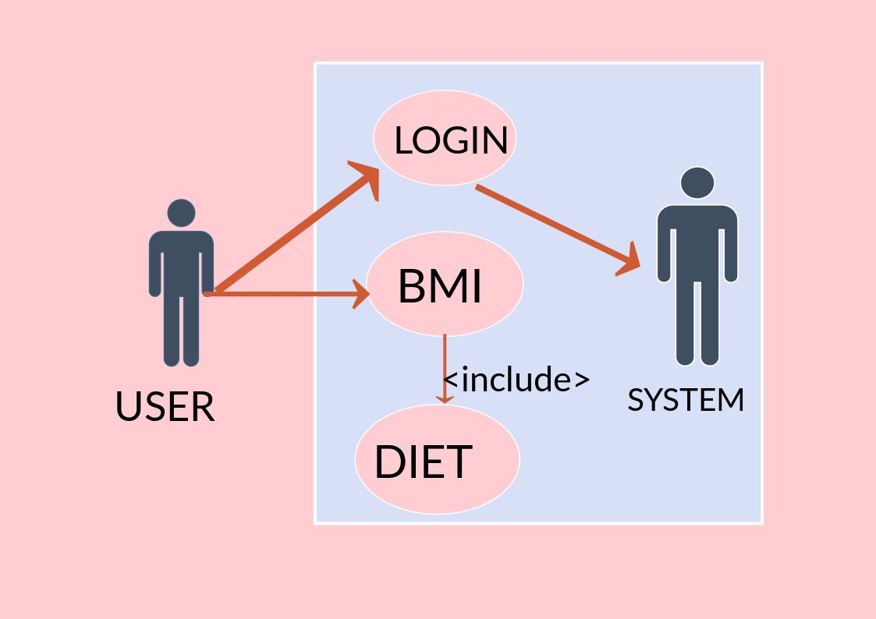

***ii.)FLOWCHART.***

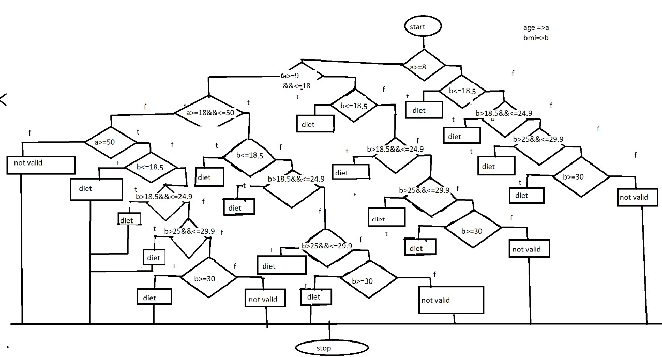

**USE CASE DESCRIPTION:-**

**Use Case ID :- UC01**

**NAME :- Login or Register**

**Actor :- User**

**Description :- Entering your details is done**

**Pre-Conditions :- None**

**Post-conditions :- None**

**User System**

**1.) Enter your details**

**2.) Validating your details**

**Use Case ID :- UC02**

**NAME :- BMI**

**Actor :- User**

**Description :- Allows user to check their BMI**

**Pre-Conditions :- None**

**Post-conditions :- None**

**User System**

**1.) Enter your details 2.) Displays BMI**

**Use Case ID :- UC03**

**NAME :- Diet**

**Actor :- User**

**Description :- Gives diet suggestions to the user.**

**Pre-Conditions :- None**

**Post-conditions :- view your diet**

**User System**

**-> Displays your diet accordingly .**

**IMPLEMENTATION OF “HEALTH IS WEALTH”.**

***i.)Description of main module and algorithm to be highlighted***

***Our Main Method Basically consists of the login details from the user which are required to certify the users body mass index which is being calculated in the main method itself and for calculation we are using math library that is <math.h>***

***Which consists power function defined in it .***

***The details which we ask the user to enter are***

1. ***Name of the User***
2. ***Weight of the user in kilograms***
3. ***Height of the user in inches (This is because every one remembers their height either in feets or inches and as these values are standard measurement for the height of a person 1feet = 12 inches using this calculation a person counts his height in inches accordingly)***

***The calculation that are required to calculate the body mass index of a person is being defined in the main method***

***Here comes the calculation part***

***Body mass index (BMI) = (Weight)/(height)^2.***

***We have used 6 functions in our project including main method***

***->Nutrition suggestion for age group classified to all four categories***

***->Function to display current date and time i.e int date_time();***

***ALGORITHM THAT ARE TO BE HIGHLIGHTED ARE***

***MAIN METHOD***

int main()

{

float WEIGHT,HEIGHT,BMI,x,ht;

int AGE;

printf("Enter your AGE :-");

scanf("%d",&AGE);

printf("Enter your weight in kgs :-");

scanf("%f",&WEIGHT);

printf("Enter your height in inches :-");

// 1 foot = 12 inches

// n'm" => n is foot and m is inches

// 5'11" = (5*12)+11 inches;

scanf("%f",&ht);

HEIGHT = ht * 0.0254;

x=pow(HEIGHT,2);

BMI=WEIGHT/x;

printf("BMI = %f\n",BMI);

}

***GITHUB LINKS:-***

***FOLDER STRUCTURE:-***

***Testing:-***

***Test case 1:-***

***Entered age and weight are 0 then***

***Bmi is not valid***

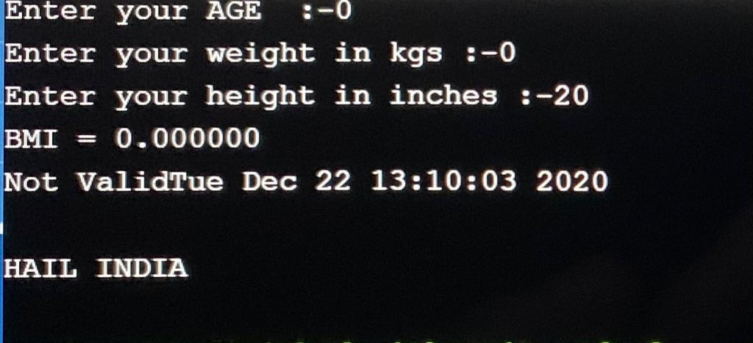

***Test case 2:-***

***Program running with successful inputs***

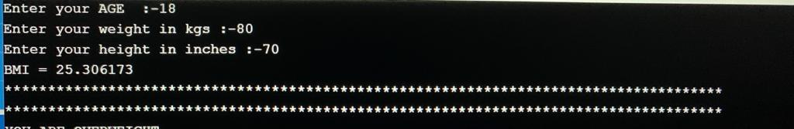

***Results:-***

***1.)First condition “A Person is overweight”***

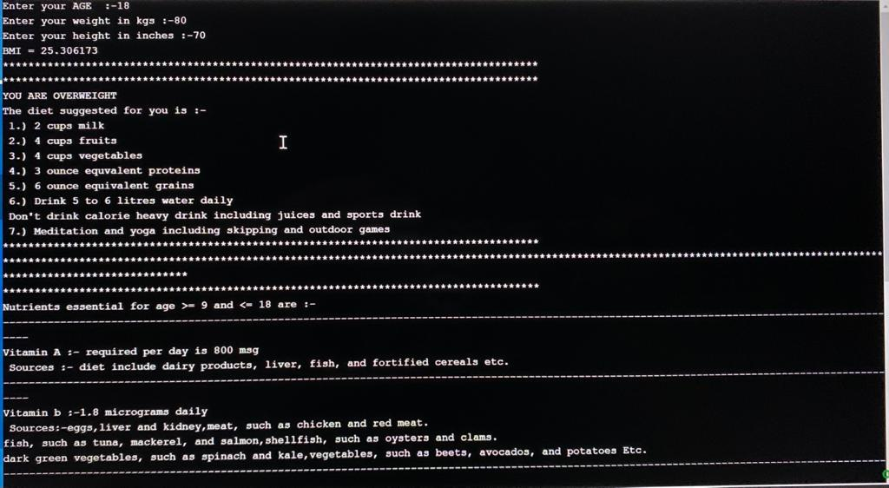

***2.)Second Condition “A Person is Normalwieght”***

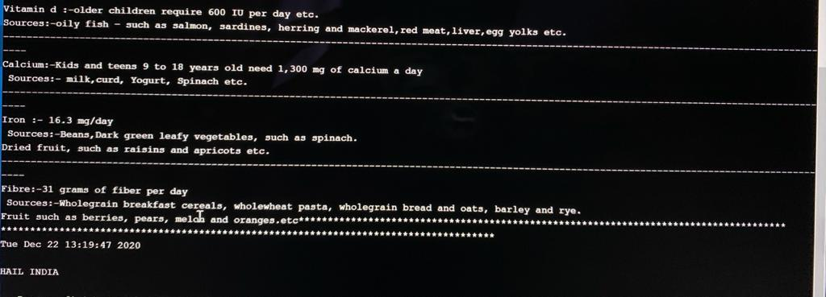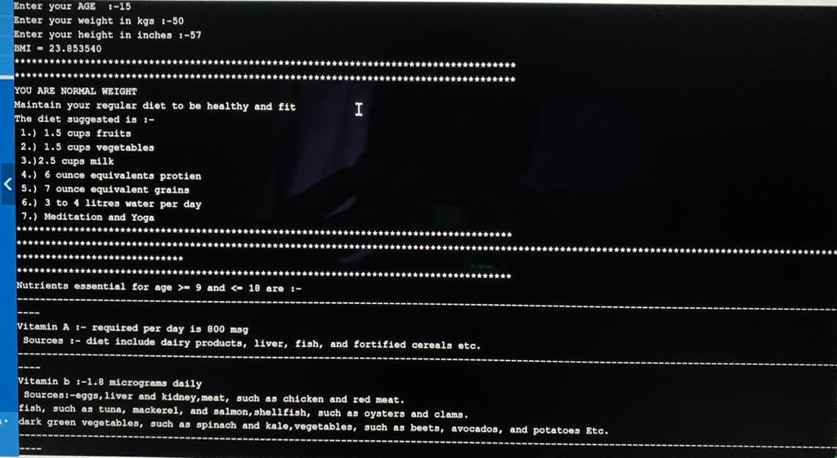

***3.)A Person is Obese***

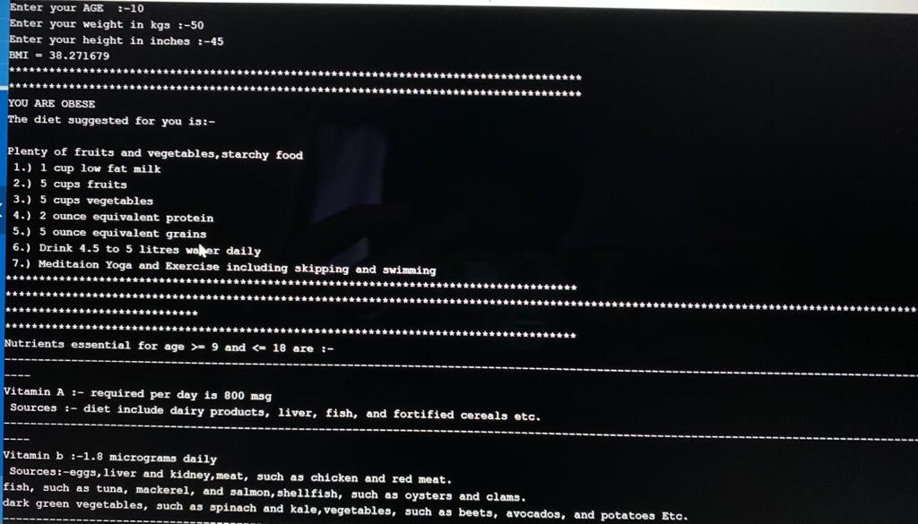

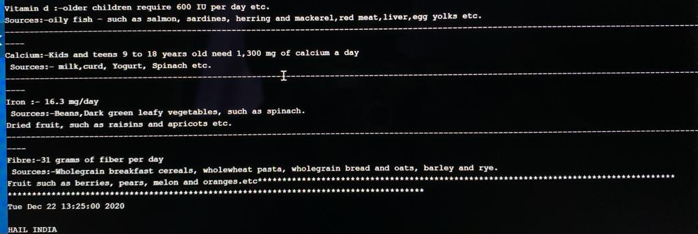

***4.)A Person Under Normal Weight Conditions***

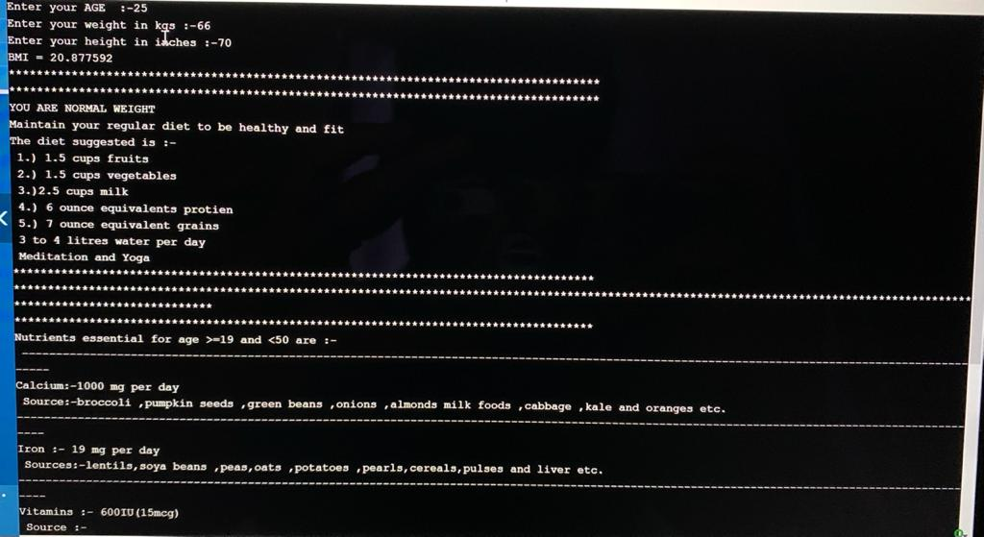

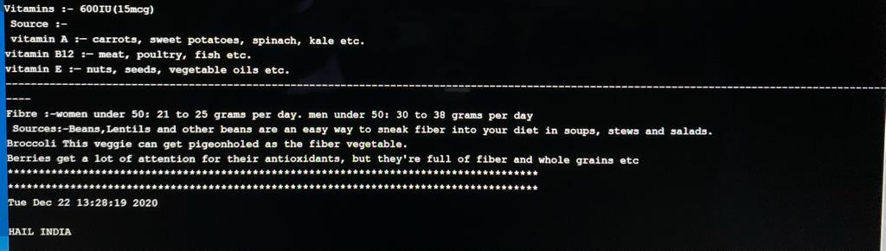

***ADDITIONAL IDEAS THAT WE LEARNT FROM DOING THIS MINI PROJECT IS***

***->WE LEARNED TO WORK AS A GROUP***

***->WE WERE TRUELY IN THE ABILITY OF ENHANCING OUR CODING SKILL***

***->WE HAVE ALSO LEARNT NEW THINGS THAT CAN BE IMPLEMENTED IN A PROGRAM***

***Implementing this project in C Language has introduced us to different libraries such as: ‘math.h’, ‘time.h’ and ‘windows.h’. We were able to use the knowledge of using standard libraries by implementing them in our project. We explored the ‘time.h’ library for achieving a look-and-feel of an actual window application by constructing our own time delay function.***

***CONCLUSION AND FUTURE WORK :-***

***We have implemented our code succesfully and our mini project is completely based on health . It primarily concentrates the health concerns that are being faced by the peolpe . Up to some extent we tried in writing a program for a healthy diet suggestion for the people and helping them to maintain a healthy and happy life .***

***The diet suggestions which we used in our program that are completely based on the norms that are certified by the world health organisation (WHO) and collected few from the recent statistics released by the Food corporation of India (FCI)***

***And we are very enthusiastic in developing an Application based on this idea (Helathy idea) and helping the people to pave their way to a W’healthy’ life.***

***Even though there are many apps of these kind in the present market but they are not that profound or well known to the people as they lack in marketing . But the app that we wanted to develop is a different one of the kind and through this marketing this app may become a successful one …………..***

***REFERNCES:-***

1. ***C LANGUAGE DOCUMENTATION***

[***https://docs.microsoft.com/en-us/cpp/c-language/?view=msvc-160***](https://docs.microsoft.com/en-us/cpp/c-language/?view=msvc-160)

***2.)DIET SUGGESTIONS***

[***https://www.who.int/***](https://www.who.int/)

[***https://fci.gov.in/***](https://fci.gov.in/)